d

Nikita Andrianov - 3328600

Catalin Badinescu - 3275639

Antanevičius Taurius – 3342166

Thaifun United Festival

Project Plan

A screenshot of a social media post

Description generated with very high confidence

Version 3

Date: 2018-03-13

Contents

Project Statement 2

Formal Client 2

Project Leader: 2

Current Situation 2

Problem description 3

Project goal 3

Project Deliverables and Non-Deliverables 3

Project Constraints 4

Project Risks 4

# Project Statement

## Formal Client

Mr. Rafayel Avetyan, teacher at Fontys ICT, the English Stream department. Fontys University located in Eindhoven. English Stream is a department in Fontys ICT, where the education is entirely given in English.

Contact information:

Rafayel Avetyan

Job title:Medewerker

Department:Engelstalige opleiding

Company:Fontys Hogeschool ICT

Office:R1

Business: 0885074073

Mobile: 0683233895

sip:r.avetyan@fontys.nl

Eindhoven

Netherlands

## Project Leader:

Taurius Antanevicius, 1st year ICT student.

Contact information

Taurius Antanevicius

Geldropseweg 126, Eindhoven

Room: 20

[t.antanevicius@student.fontys.nl](mailto:t.antanevicius@student.fontys.nl)

+31684149656

Working days: Monday – Friday.

## Current Situation

Nowadays there are various events in order to entertain people. One of the biggest type are music festivals which usually attract huge amount of people. Those, who organise this kind of event invest decent amount of money in order to make profit. Usually the tickets of the entrance, of the camping and some things inside are sold and cash is not always the most comfortable way to pay for everything. When it comes to huge data and more than just hundreds of visitors, people without software would have much harder time to make all systems manageable, more comfortable and secure. In addition, more people means bigger probability of chaos and uncontrollable actions, that's why security should be considered responsibly. Furthermore, organisers want to collect data about their festivals. And all these things make people consider about using software solutions.

Our client,Mr. Rafayel, wants to organise music festival in Uttrecht, Netherlands. The name of the festival is „Thaifun United Festival“. He wants to get several software solutions in order to organise the event and turn his ideas into reality. First of all, there is entrance where people need to be checked, who bought tickets, can enter to event inside zone. Inside visitors can go straight to stages to listen music. People who want to buy food or drinks or loan some extra things (cameras) should be able to buy/borrow them without cash using provided solution . People can go to camping area through the camping entrance place while they are inside of the event.

## Problem description

Since the client organizes a big event with a lot of facilities he faces some problems. First of all, Mr. Rafayel needs to have the system for people to enter into the festival area, as well as to camping only for people who own tickets (including camping). Also, client wants to sell tickets online since it’s one of the most comfortable way for both, visitors and a client. In addition, he wants to sell food, drinks and loan materials without any use of cash. He needs to keep track of loaned items as well. The client wants to know the statistic about quantity of people who were in festival, as well, see how many people are present in order that festival would be manageable. All these problems can be solved with several software solutions.

## Project goal

Bring these software solutions to the client for:

* + **Visitor status & Visitor history** - to see information about every individual visitor.
  + **Visitors present at the event** - to see how many people are inside of event.
  + **Visitors present at every stage** – to avoid overcrowding in a certain stage.
  + **Total visitors** – statistics how many people in total visited the whole event.
  + **Total balance of all visitors together & total spent money** – statistics asked by a client.
  + **Camping statistics** - booked and free spots so that visitors can select where they want to stay.
  + **Total money sold per shop** – statistics asked by a client.
  + **Total amount of a certain product sold** - statistics asked by a client.
  + **Method of payment inside of the event** - so that visitors can buy/rent available things without using cash.

## Project Deliverables and Non-Deliverables

In this project, the deliverables are:

* An application to be used (at the):

1. entrance of the event (for entrancing and leaving)
2. entrance of the camping
3. shops
4. stand, where you can loan materials
5. for tracking status of the event
6. An application to convert the information in the transaction-log-file to the database

* A website for buying tickets, advertising the event, checking the schedule of performances, adding money to account, sending tickets (unique codes) to customers.
* User manual for every application
* Age constraint based on the country
* Use of R-FID technology
* Design document
* User requirements specification

We will not deliver:

* Training for users will not be offered, since the user manual can be used to learn how to work with applications
* We are not going to provide RFID bracelets which will be used at entrances, but we will make them work properly

## Project Constraints

*Constraint 1: Time*

The project must be completed within 5 months.

*Constraint 2: Budget*

The budget for this project is 20 weeks.

*Constraint 3: English Language*

In order that international as well as Dutch people would be able to properly use applications.

*Constraint 4: R-FID*

For people to have individual accounts inside of the festival and use them (in shops, etc.) we use R-FID technology and bracelets.

*Constraint 5: C# for applications*

For applications we are going to use C# programming language.

*Constraint 6: HTML, CSS, JavaScript, PHP for web development*

We are going to use these languages to create website and meet all required requirements.

## Project Risks

|  |  |  |  |  |  |  |
| --- | --- | --- | --- | --- | --- | --- |
|  | **Risks:** | **Probability** | **Impact on project** | Steps to prevent | | Clean up action |
| 1. | **Poor organization and not all software applications are completed** | Low | High | Add more worktime on project and consult with experienced people. | | Talk tutor how to organize time for different applications. |
| 2. | **The applications interface are not intuitive enough** | Low | Medium | Test the interface with group of people. | | Explain step by step how to use applications in the manual. |
| 3, | **The website is down in the event** | Low | Medium | Have a back-up server. | | Run website on back-up server. |
|  |  |  |  | |  |  |

## Project Phasing:

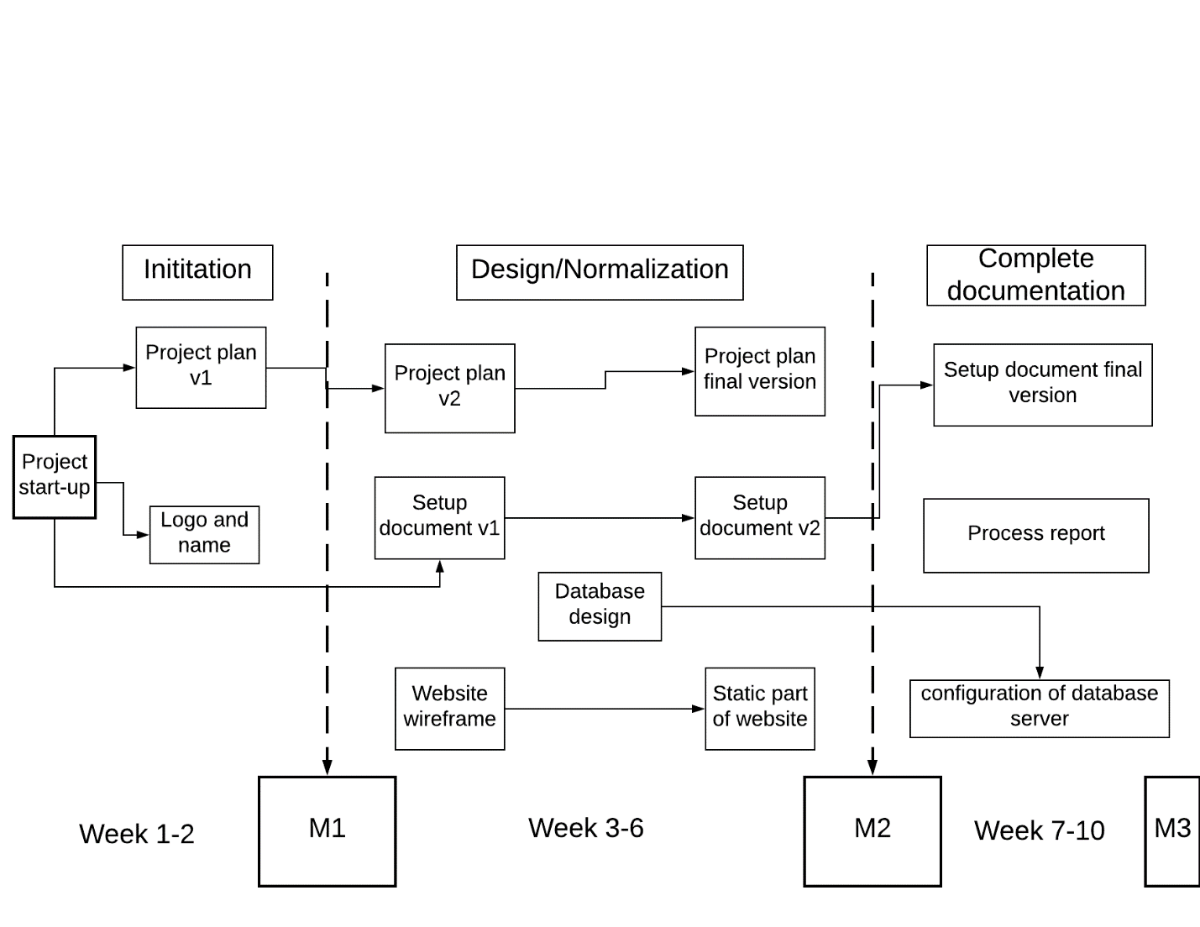

### 

### Phase 1: Initiation

Duration: Week 1-2.

Activity: Start-up the project

Tasks for the activity are:

* Interview client
* Discuss current situation, problems, desired end situation
* Set the project goal together with the client
* Kick off meeting
* Create a logo and name

Deliverables for milestone M1 are:

* Detailed division of work amongst team members
* The Project plan version 1
* Logo
* Name

### Phase 2: Documentation continuation

Duration: Week 3-6.

Activity: documentation

Tasks for the activity are:

* Create improved project plan (version 2) based on feedback from version 1.
* Create final project plan
* Make the agreements with the client
* Create Setup document version 1
* Create Setup document version 2 based on feedback from version 1
* Create mind map for the site
* Installing Jet Brain PHP Storm and other tools for website development
* Create website wireframe
* Create website (static part)
* Create database design

Deliverables for milestone M2 are:

* Final project plan
* Setup document version 2
* Website wireframe
* Website’s static part
* Database design

### Phase 3: Complete documentation.

Duration: week 7-10.

Activity: finish documentation and start research

Tasks for the activity are:

* Finish setup document final version
* Installing visual studio for C# applications
* Installation and configuration of database server – figure out available servers which we can use
* Process report

Deliverables for milestone M3 are;

* Setup document final version.
* Process report

### Phase 4: Build

Duration: week 11-14.

Activity : Implement fully functional website

Tasks for this activity are:

* Implement final interface of the website
* Upload website source files
* Check if website is internationalization ready
* Make website user-friendly
* Check that generic content, such as lorem ipsum, has been properly removed and replaced

Activity : Implement software

Tasks for this activity are :

* Implement application for entrance of camping
* Implement application for entrance of festival
* Implement application for shops
* Implement application for loan stands
* Implement application for checking status of event
* Implement application for checking people while they are leaving the festival for loaned materials
* Upload software source code

Activity : Implement database

Tasks for this activity are :

* Create database
* Connect database and website
* Connect database and software

Deliverables for milestone M4 are :

* Fully functional website
* Generated database
* Connection between database and functional website
* Connection between database and software
* All required applications

### Phase 5: Test

Duration : Week 14-17.

Activity: Testing website

Tasks for this activity are :

* Functionality testing
  + Checking all the links
  + Test forms on all pages
  + Cookies testing
  + Database testing
  + Validation of HTML and CSS
* Usability testing
  + Ease of learning
  + Subjective user satisfaction
  + Content checking
* Interface testing

Activity: Testing software

Tasks for this activity are :

* Black box testing
  + Checking if software does what it has to do
* White box testing
  + If application falls try to find it's cause
* Dynamic testing
  + The software is executed with various inputs, and testers compare outputs with expected behavior with this method.
* GUI testing
  + Testing text formatting, text boxes, buttons, lists, layout, colors, fonts, font sizes,
* Usability testing
  + Testing how well the GUI is designed and its ease of use

Activity: Testing database

Task for this activity is :

* Functional Testing

Deliverables for milestone M5 are :

* Updated process report
* Website is tested
* Software is tested
* Database is tested
* Issues and weaknesses are

### Phase 6: Finalization

Duration 17-18 week

Activity: Work on final state of deliverables

Tasks for this activity are :

* Finalize and hand in all deliverables
* Arrange final meeting with the client

Deliverables for milestone M6 are :

* All deliverables are finalized
* Source code is uploaded
* Preparation for presentation is started

### Phase 7: Presentation

Duration 18-20 week

Activity: Present product to the client

Tasks for this activity are :

* Finish presentation
* Present product to client

Deliverables for milestone M7 are :

* Presentation

# Time:

|  |  |  |  |
| --- | --- | --- | --- |
| **Milestone** | **Deliverable** | **Due Date** | **Estimated time** |
| **M1 Initiation** | Project Plan v1 | 27 February | 2 weeks |
| **M2 Design/Normalization** | Final Project Plan,  Setup Document V2 | 27 March | 4 weeks |
| **M3 Complete documentation** | Setup Document Final Version,  Process Report V1 | 24 April | 4 weeks |
| **M4 Build** | Website,  Software, Database connection | 22 May | 4 weeks |
| **M5 Test** | Improve functionality | 19 June | 4 weeks |
| **M6 Finalization** | Final edition of all deliverables | 3 July | 2 weeks |
| **M7 Presentation** | Presentation | 17 July | 2 weeks |

# Skills:

|  |  |
| --- | --- |
| Skills | Description |
| Communication skills | A critical part in a project is communication. It’s a challenge between the parties because if it’s not done correctly then it will have a high impact on the time spent project but also on its overall quality. |
| Research skills | It’s needed for gathering information and documenting it. There needs to be a balance between the amount of information and the quality of the information gathered. The researchers need to have a critical thinking, excellent methods of reporting and documenting, a clear view about recognizing research problems that could arise. |
| Programming skills | Technical programming skills are needed for creating the applications. For the development of the software applications there is a need of an object-oriented programmers (C#), database modeling and designers and web developers using the latest frameworks available. |
| Designing skills | The designer needs to create an excellent harmony between visual communication and design interaction. |
| Testing skills | Testing is the last wall between the developers and the client. Testers needs to use good test strategies and tools, strong guidelines, great communication with the developers |

# Information

|  |  |  |  |  |
| --- | --- | --- | --- | --- |
| Person | Project Plan | Process Report | Setup Document | Deliverables |
| Project Leader | Draw up  Send  Archive | Draw up  Send  Archive | Draw up  Send  Archive | Send  Archive |
| Project Members | Draw up  Archive | Draw up  Archive | Draw up  Archive | Archive |
| Client | Discuss  Receive  Approve | Discuss  Receive  Approve | Discuss  Receive  Approve | Discuss  Receive  Approve  Archive |
| Tutor | Discuss  Receive  Approve | Discuss  Receive  Approve | Discuss  Receive  Approve | Discuss  Receive |

# Organization

There are 3 parties involved in his project:

**Client**

Rafayel Avetyan

**Tutor**

Shaghelani Mikaeil

**EVENTUS Team**

Bădinescu Marius Cătălin

Nikita Andrianov

Antanevičius Taurius